**Setup New Site at** [**http://www.simpsf.com/site/?signup=1**](http://www.simpsf.com/site/?signup=1)

Collect 3 pieces of information to set up their site.

1. Company Name (This we should have before call)
2. Payroll/Owner Name (If possible, get this before call)
3. Email Address

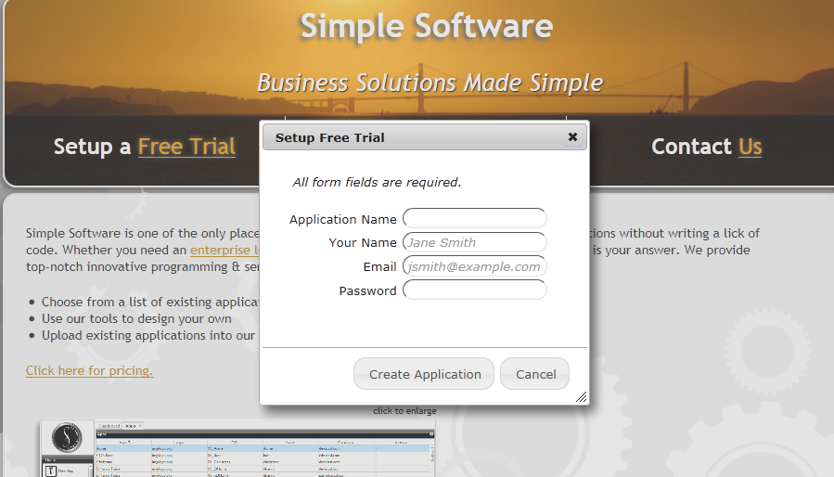

Use the information above to fill out the form:

* Application Name = Company Name (Use Capitalization and spaces. For example: “Simple Software”)
* Your Name = Payroll/Owner Name
* Email = Their Email address
* Password = simple1

**Employee**

Add “Employee” record to system, using email address above, in order to demo Timeclock

1. Login to site using email address and “simple1” as password
2. Click on Administrator, then click on Employee
3. Click on New button
4. Enter information below and then click save
   1. Make sure you fill out the fields properly and set the record to Active!!!
5. Have customer log in using the email address

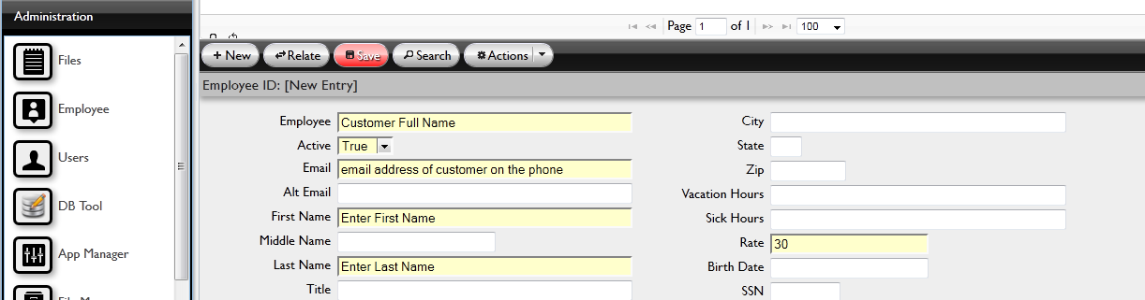

If you entered everything properly, log out then log back in to sync user to employee. If you forgot to set employee to active, they will not be able to clock in!!

**TimeClock**

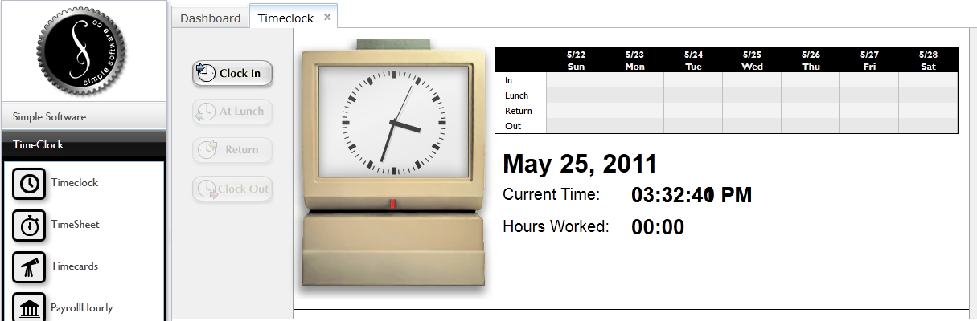

Click all of the buttons starting with ‘Clock In’ in order to generate some demo data. Once you’ve ‘Clock Out’ for the day, the buttons should all be grey. Continue below.

**TimeSheet**

TimeSheet allows the employee to view their timesheet without making changes.

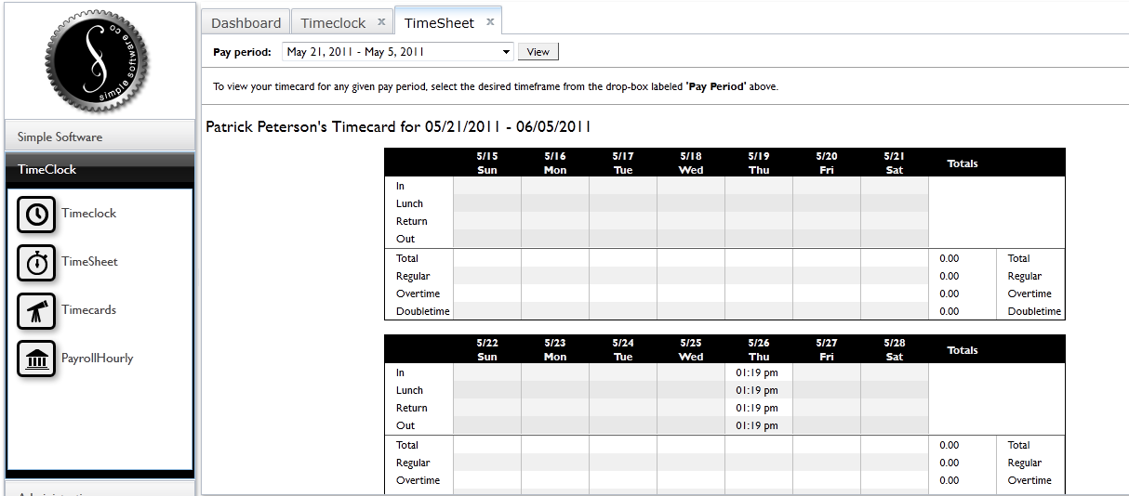

Timecards

Managers can use Timecards to make changes to an employee’s punches or to add one if an employee forgot to punch in or out. Time is entered in 100 parts of an hour. 12:50p = 12:30p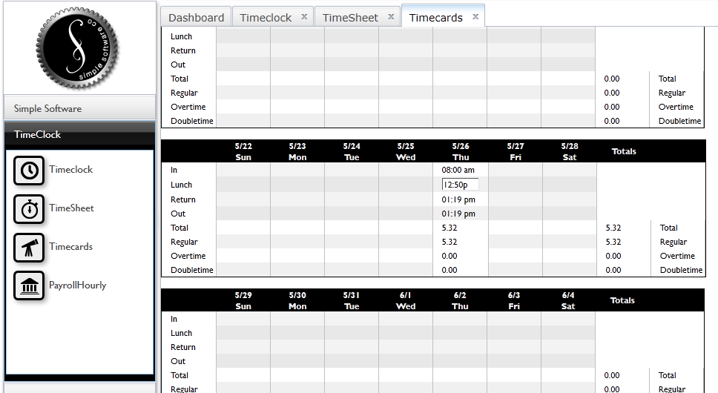

**Payroll**

Generating payroll is as simple as selecting the pay period and clicking a button. The system will download a spreadsheet to your local computer which will have a breakdown by employee.

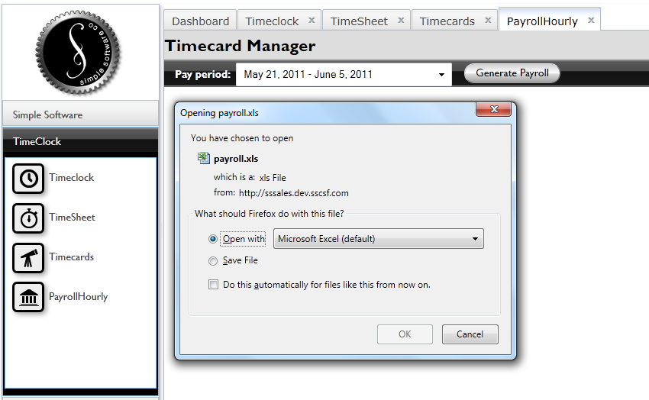

The calculations are based on the rate entered into the Employee record.

